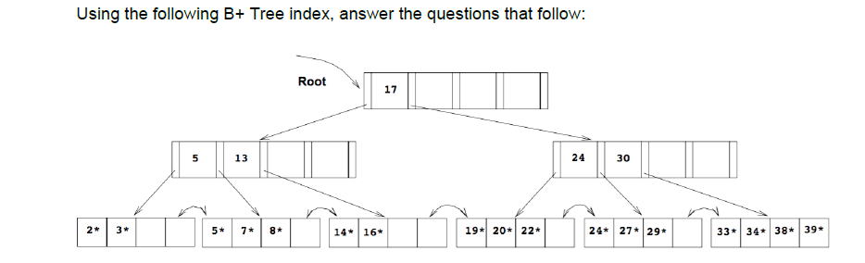

Show the resulting B+Tree after

1. Inserting data entry 37\*

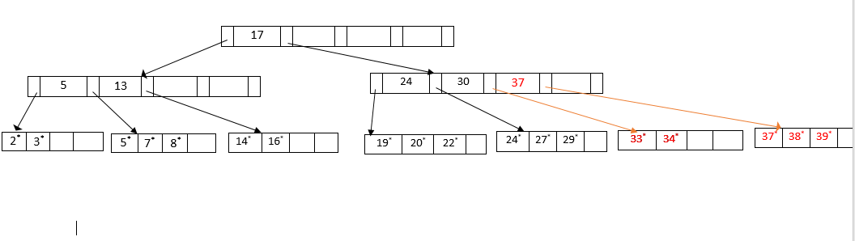

1. Inserting data entry 6\*

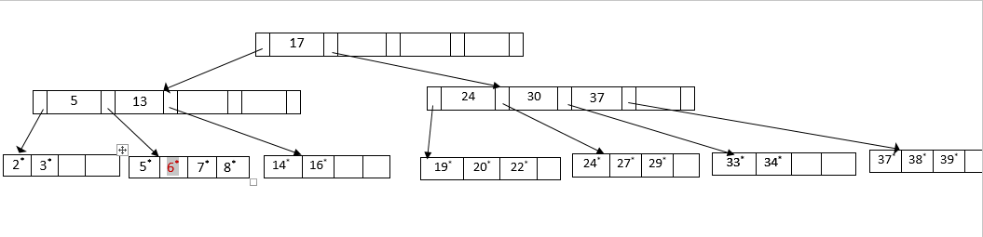

1. Inserting data entry 18\*

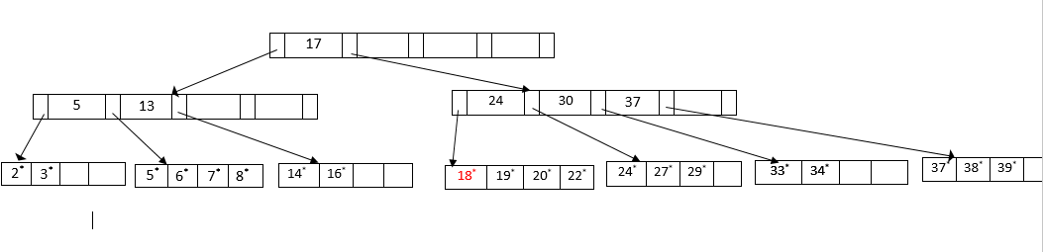

1. Deleting data entry 3\*

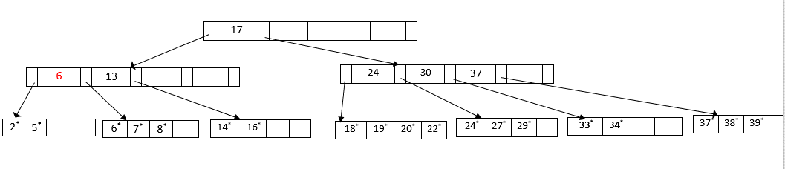

1. Deleting data entry 5\*

